**04 - Divide and Conquer**

|  |  |
| --- | --- |
| **Ex. No. : 4.1** | **Date: 03.09.24** |
| **Register No.: 230701353** | **Name: SURYA E** |



**Problem Statement:**

**Given an array of 1s and 0s this has all 1s first followed by all 0s. Aim is to find the number of 0s. Write a program using Divide and Conquer to Count the number of zeroes in the given array.**

**Input Format**

**First Line Contains Integer m – Size of array**

**Next m lines Contains m numbers – Elements of an array**

**Output Format**

**First Line Contains Integer – Number of zeroes present in the given array.**

ALGORITHM:

Step 1: Start

Step 2: Read the value of n from the user and initialize an array arr of size n. Read n values into the array.

Step 3: Check if the first element of arr is 0. If true, print n and exit the program.

Step 4: Call the divide function with arr, 0, and n-1 to find the index of the first occurrence of 0.

Step 5: If the index is not 0, print the value of n - index, which represents the count of 0s in the array. Otherwise, print the index.

Step 6: End

PROGRAM:

#include <stdio.h> int divide(int [],int,int); int divide(int a[],int left,int right)

{

int mid=0;

mid=left+(right-left)/2; if (a[0]==0) return 0; else if (a[right-1]==1) return right; if ((a[mid]==0) && (a[mid-1]==0)) return divide(a,0,mid); else if (a[mid]==0) return mid; else return divide(a,mid+1,right);

}

int main()

{

int n; scanf("%d",&n); int arr[n]; for (int i=0;i<n;i++)

{

scanf("%d",&arr[i]);

}

int zero=divide(arr,0,n); printf("%d",n-zero);

}

OUTPUT:

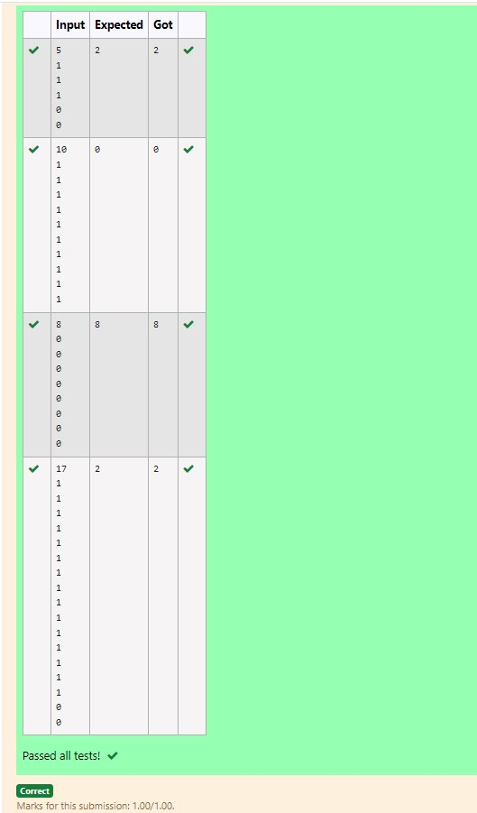

RESULT :

Hence the above program has been executed successfully.

|  |  |
| --- | --- |
| **Ex. No. : 4.2** | **Date: 03.09.24** |
| **Register No.: 230701353** | **Name: SURYA E** |



AIM:

**Given an array nums of size n, return *the majority element*.**

**The majority element is the element that appears more than** ⌊**n / 2**⌋ **times. You may assume that the majority element always exists in the array.**

**Example 1:**

**Input: nums = [3,2,3]**

**Output: 3**

**Example 2:**

**Input: nums = [2,2,1,1,1,2,2]**

# Output: 2

**For example:**

|  |  |
| --- | --- |
| **Input** | **RESU**  **LT** |
| **3**  **3**  **2**  **3** | **3** |
| **7**  **2**  **2**  **1**  **1**  **1**  **2**  **2** | **2** |

ALGORITHM:

Step 1: Start

Step 2: Read the value of n from the user and initialize an array arr of size n. Read n values into the array.

Step 3: Use qsort to sort the array arr in ascending order.

Step 4: Loop through the array to find the first and last indices of each element using the first and last functions. Calculate the count of occurrences (major).

Step 5: If any element's count is greater than or equal to n/2, return that element.

Step 6: Print the element that appears more than n/2 times or print 0 if none is found.

Step 7: End

PROGRAM:

#include <stdio.h> int mid=0,c=0; int Count(int [],int,int,int); int Count(int a[],int left,int right,int key)

{

int mid=left+(right-left)/2; if (a[mid]!=key)

{

Count(a,left,mid,key);

Count(a,mid+1,right,key);

}

else

{

c++;

}

return c;

}

int main()

{

int n; scanf("%d",&n); int arr[n]; for (int i=0;i<n;i++) scanf("%d",&arr[i]); int k=arr[0]; if (Count(arr,0,n,k)>n/2) printf("%d",k); else

{

for (int i=0;i<n/2;i++) if (arr[i]!=k)

{

printf("%d",k); break;

}

}

}

OUTPUT:

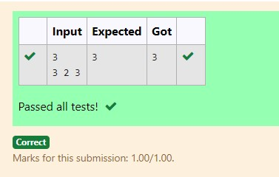

RESULT :

Hence the above program has been executed successfully.

|  |  |
| --- | --- |
| **Ex. No. : 4.3** | **Date: 03.09.24** |
| **Register No.: 230701353** | **Name: SURYA E** |



AIM:

**Problem Statement:**

**Given a sorted array and a value x, the floor of x is the largest element in array smaller than or equal to x. Write divide and conquer algorithm to find floor of x.**

**Input Format**

**First Line Contains Integer n – Size of array**

**Next n lines Contains n numbers – Elements of an array**

**Last Line Contains Integer x – Value for x**

**Output Format**

**First Line Contains Integer – Floor value for x**

ALGORITHM:

Step 1: Start

Step 2: Read the value of n from the user and initialize an array arr of size n. Read n values into the array.

Step 3: Read the integer x from the user, which will be used to find the floor value.

Step 4: Call the search function with arr, x, 0, and n-1 to find the largest element in arr that is less than or equal to x.

Step 5: Print the floor value returned by the search function.

Step 6: End

PROGRAM:

#include<stdio.h> int search(int[],int,int,int);

int search(int arr[],int x,int left,int right)

{

int mid=left+(right-left)/2;

if(arr[mid]<=x)

{

int max = arr[mid];

for(int i=0;i<mid;i++){ if(arr[i]>=max) max=arr[i];

}

return max;

}

else if(arr[mid]>x)

{

return search(arr,x,left,mid);

}

else

return search(arr,x,mid+1,right);

}

int main()

{

int n,x,floor; scanf("%d",&n); int arr[n]; for(int i=0;i<n;i++){

scanf("%d",&arr[i]);

}

scanf("%d",&x); floor = search(arr,x,0,n-1); printf("%d",floor); return 0;

}

OUTPUT:

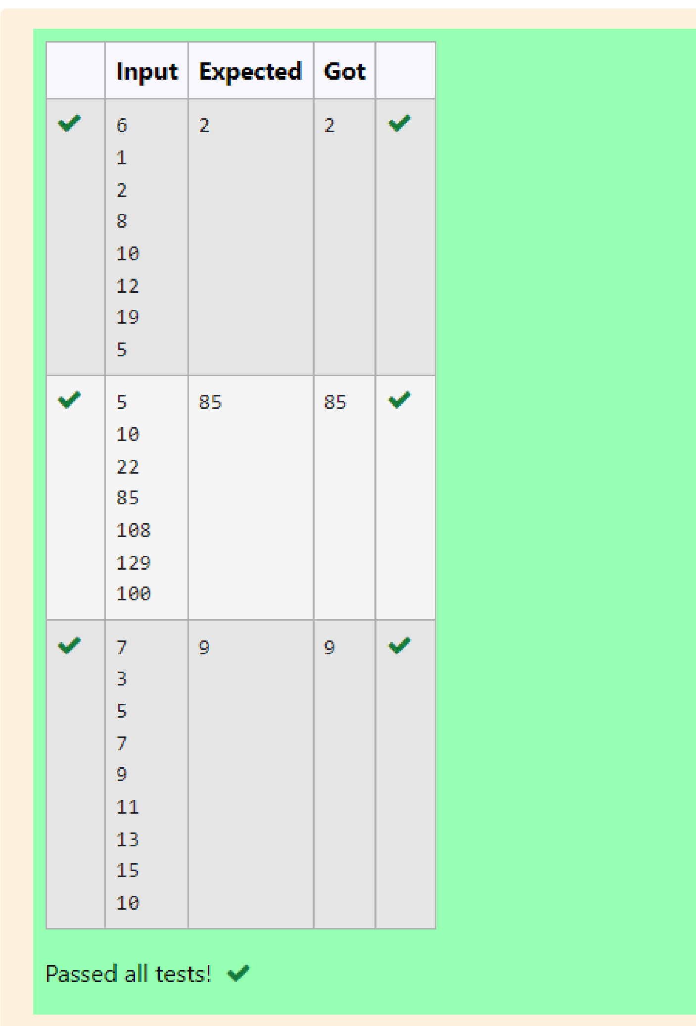

RESULT :

Hence the above program has been executed successfully.

|  |  |
| --- | --- |
| **Ex. No. : 4.4** | **Date: 03.09.24** |
| **Register No.: 230701353** | **Name: SURYA E** |



AIM:

**Problem Statement:**

**Given a sorted array of integers say arr[] and a number x. Write a recursive program using divide and conquer strategy to check if there exist two elements in the array whose sum = x. If there exist such two elements then return the numbers, otherwise print as “No”.**

**Note: Write a Divide and Conquer Solution**

**Input Format**

**First Line Contains Integer n – Size of array**

**Next n lines Contains n numbers – Elements of an array**

**Last Line Contains Integer x – Sum Value**

**Output Format**

**First Line Contains Integer – Element1**

**Second Line Contains Integer – Element2 (Element 1 and Elements 2 together sums to value “x”)**

ALGORITHM:

Step 1: Start

Step 2: Read the value of n from the user and initialize an array arr of size n. Read n values into the array.

Step 3: Read the integer x from the user, which represents the target sum.

Step 4: Call the twosum function with arr, 0, n-1, and x to find two numbers in the array that add up to x.

Step 5: If a pair is found, print the two numbers; otherwise, print "No" to indicate that no such pair exists.

Step 6: End

PROGRAM:

#include<stdio.h> void twosum(int arr[],int left,int right,int x){ if (left >= right){ printf("No"); return;} int sum=arr[left]+arr[right]; if (sum==x){ printf("%d\n",arr[left]); printf("%d\n",arr[right]);

}

else if(sum<x){ twosum(arr,left+1,right,x);

}

else{ twosum(arr,left,right-1,x);

}

}

int main(){ int n,x; scanf("%d",&n); int arr[n]; for (int i=0;i<n;i++){ scanf("%d",&arr[i]);

}

scanf("%d",&x); twosum(arr,0,n-1,x); return 0;

}

OUTPUT:

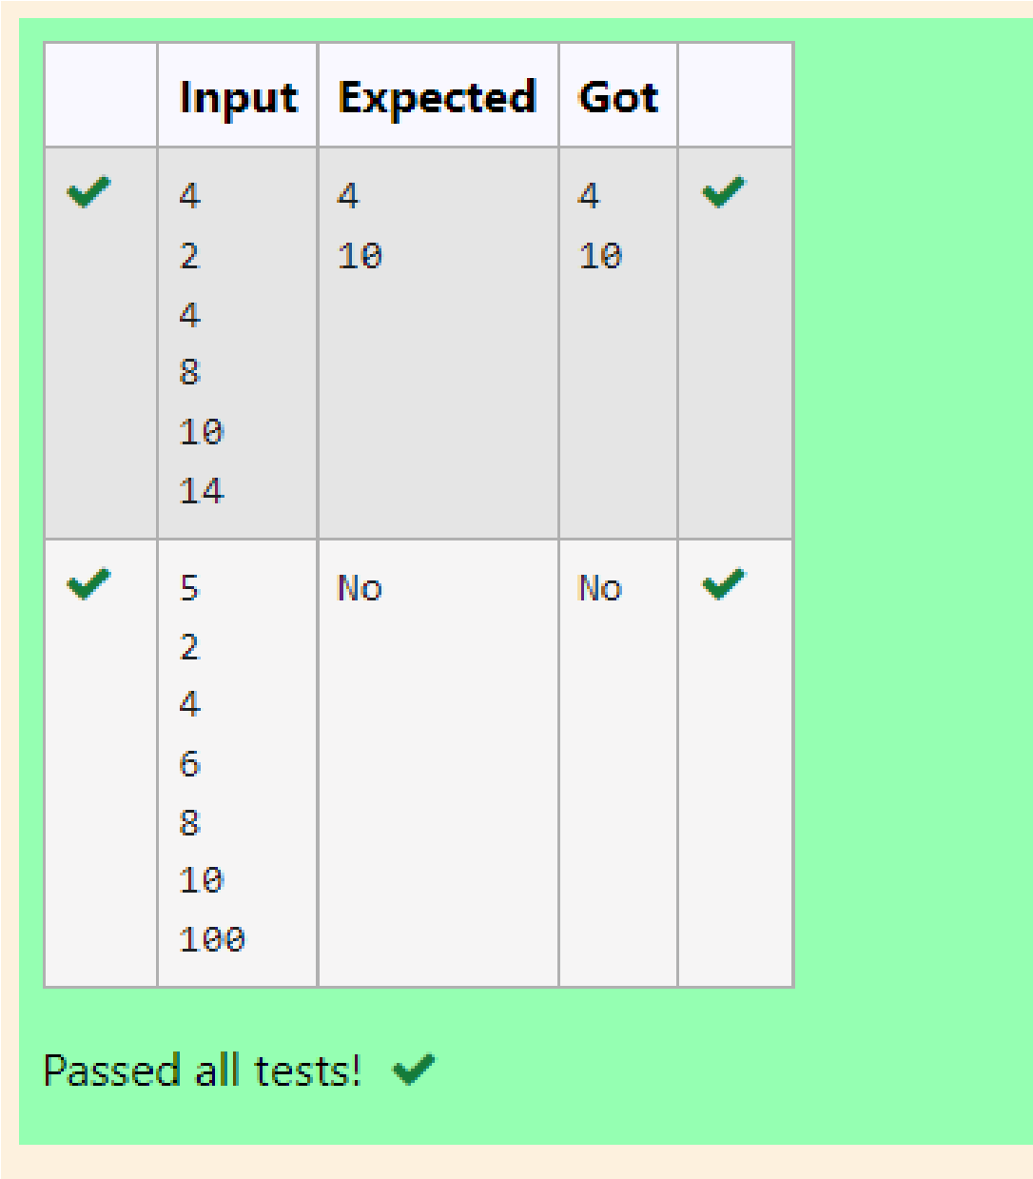

RESULT :

Hence the above program has been executed successfully..

|  |  |
| --- | --- |
| **Ex. No. : 4.5** | **Date: 03.09.24** |
| **Register No.: 230701353** | **Name: SURYA E** |



AIM:

**Write a Program to Implement the Quick Sort Algorithm**

**Input Format:**

**The first line contains the no of elements in the list-n The next n lines contain the elements.**

**Output:**

**Sorted list of elements**

**For example:**

|  |  |
| --- | --- |
| **Input** | **RESULT** |
| **5**  **67 34 12**  **98 78** | **12 34 67**  **78 98** |

ALGORITHM:

Step 1: Start

Step 2: Read the value of n from the user and dynamically allocate an array arr of size n. Read n values into the array.

Step 3: Call the q_sort function with arr, 0, and n-1 to sort the array using the Quick Sort algorithm.

Step 4: In the q_sort function, select a pivot and partition the array into two halves. Recursively apply the same sorting process to both halves.

Step 5: Once sorted, iterate through the array and print the sorted values.

Step 6: End

PROGRAM:

#include<stdio.h> void quicksort(int arr[],int left,int right){ if(left<right){ int j=right; int i=left; int pivot=left; while(i<j){ while(arr[i]<=arr[pivot]){ i++;} while(arr[j]>arr[pivot]){ j--; } if(i<j){

int temp=arr[i]; arr[i]=arr[j]; arr[j]=temp;

}

OUTPUT:

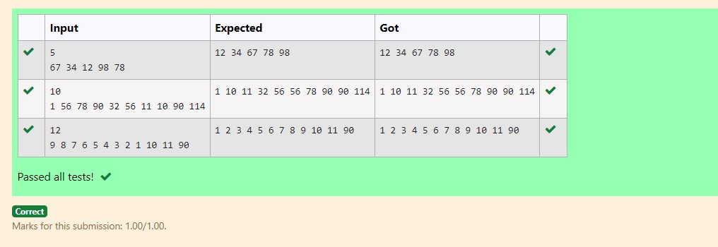

RESULT :

Hence the above program has been executed successfully..